P vs NP Demonstrator — Final Project Report
Abstract
This project investigates NP-Complete problems by implementing exact solvers, performing polynomial-time reductions, and conducting runtime experiments. The exponential growth in computation time shown by the results emphasizes the fundamental difficulty of such problems. These findings support the theoretical belief that, unless P = NP, solving NP-Complete problems efficiently remains infeasible.
1. Introduction
The P vs NP problem is one of the seven Millennium Prize Problems. It asks:
If a solution to a problem can be verified quickly (in polynomial time),
can it also be found quickly?
Class P includes problems solvable in polynomial time.
Class NP includes problems whose solutions can be verified in polynomial time.
Some problems are NP-Complete, meaning:
- They are in NP
- Every NP problem can be reduced to them in polynomial time
- They are the hardest problems in NP
In this project, we study three NP-Complete problems:
- Boolean Satisfiability (3-SAT)
- Subset Sum
- Vertex Cover
Polynomial reductions among these problems demonstrate their computational equivalence.
What is 3SAT?
3SAT is a decision problem from Boolean logic. It asks whether the variables of a given Boolean formula can be assigned True or False values such that the entire formula evaluates to True.
Formula Structure:
The formula must be in Conjunctive Normal Form (CNF), meaning it is a conjunction (AND) of several clauses.
Clause Structure:
Each clause must be a disjunction (OR) of exactly three literals.
A literal is a variable or its negation (e.g., x1 or ¬x1).

Formal Definition
Given a Boolean formula φ in 3-CNF, the question is:
Does there exist a truth assignment that makes φ true?
φ = (L1,1 OR L1,2 OR L1,3) AND (L2,1 OR L2,2 OR L2,3) AND … AND (Lm,1 OR Lm,2 OR Lm,3)
where Li,j is a literal (a variable xk or its negation ¬xk).

Example
Is the following formula satisfiable?
(x1 OR ¬x2 OR x3) AND (¬x1 OR x2 OR ¬x3) AND (x1 OR x2 OR x3)
Satisfying Assignment:
If we set x1 = True, x2 = True, x3 = False, then all clauses evaluate to True → formula is True → Answer: Yes.
Unsatisfiable Formula:
If no truth assignment can satisfy the formula → Answer: No.

NP-Completeness of 3SAT
The proof consists of two parts:

1) 3SAT is in NP
Certificate: A truth assignment for the variables
Verification: Substitute values and check if every clause is True
This takes polynomial time: O(N * M)
(N = number of variables, M = number of clauses)

2) 3SAT is NP-hard (Cook-Levin Theorem)
The Cook-Levin theorem proves that:
- Every problem in NP can be reduced to SAT
- SAT can be reduced to 3SAT
- All reductions are polynomial time
This makes 3SAT a fundamental NP-hard problem.

Core Idea of the Reduction
- Start with any NP problem A
- Because A is in NP, there exists a polynomial-time Verifier
- Encode the Verifier’s computation using Boolean variables
- Build a 3SAT formula φ that is satisfiable iff the Verifier accepts the input
Thus:
Solving 3SAT efficiently would solve every NP problem efficiently → P = NP.

Brute-Force Runtime for 3SAT
Since 3SAT is NP-complete:
Brute-force approach:
Try all truth assignments for N variables → 2^N possibilities
Runtime:
O(2^N * poly(N))
This is exponential time in the number of variables.
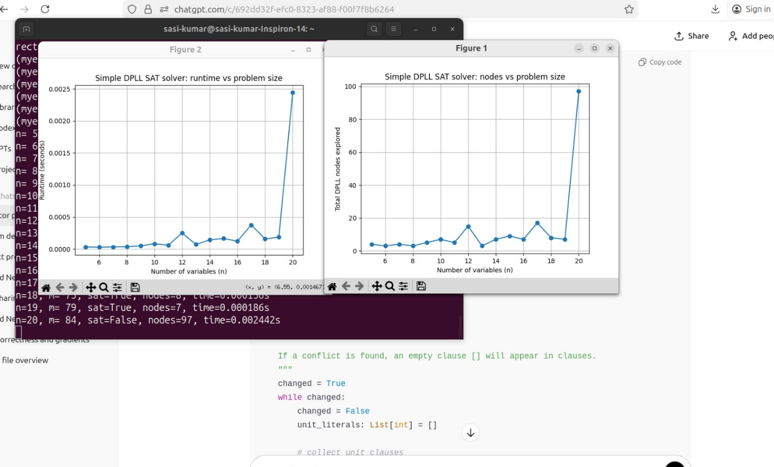
Subset Sum Problem — Complexity Analysis
The Subset Sum Problem asks whether a subset of a given set of numbers S sums up exactly to a target value T. Subset Sum is an NP-complete problem.
The comparison between Brute Force and Dynamic Programming (DP) for Subset Sum shows how DP uses overlapping subproblems to greatly improve runtime, although its efficiency depends on the target sum T.

Brute Force Approach: Exponential Time
The naive way to solve Subset Sum is to check every possible subset of the input numbers.
Method:
Recursion or backtracking is used. For each element, there are two choices:
- Include the element in the current subset
- Exclude the element from the current subset
Time Complexity:
Since there are N elements, each can be included or excluded → 2^N possible subsets
O(2^N)
This runtime becomes impractical even for moderate N (example: N = 50).
The brute-force method also recomputes the same intermediate results repeatedly.

Dynamic Programming Approach: Pseudo-Polynomial Time
Dynamic Programming avoids recomputation by storing results in a table.
Method:
A 2D boolean table DP[i][j] is constructed:
- i: index of elements (0 to N)
- j: current target sum (0 to T)
- DP[i][j] = True if a subset of first i elements can sum to j
Recurrence relation:
DP[i][j] = DP[i-1][j] OR DP[i-1][j - arr[i-1]]
Meaning:
- DP[i-1][j]: exclude the element
- DP[i-1][j - arr[i-1]]: include the element if possible
Time Complexity:
O(N * T)
This is efficient when T is not too large.
Pseudo-Polynomial:
The runtime is polynomial in N and T, but T itself can be exponentially large in terms of bit-length of input numbers, so the algorithm is not fully polynomial.

Comparison Table
Feature | Brute Force (Recursion/Backtracking) | Dynamic Programming (DP)
Time Complexity | O(2^N) | O(N * T)
Nature | Exponential | Pseudo-Polynomial
Pros | Simple to implement, minimal space overhead | Very effective when T is reasonably small
Cons | Not feasible for N > 40 | Slow when T is very large
Core Technique | Try all subsets | Store intermediate sum results

Summary
Subset Sum is NP-complete, meaning:
- No known polynomial-time solution exists based only on N
- Exact solutions require either:
Exponential time (Brute Force), or
Pseudo-polynomial time based on target sum T (DP)
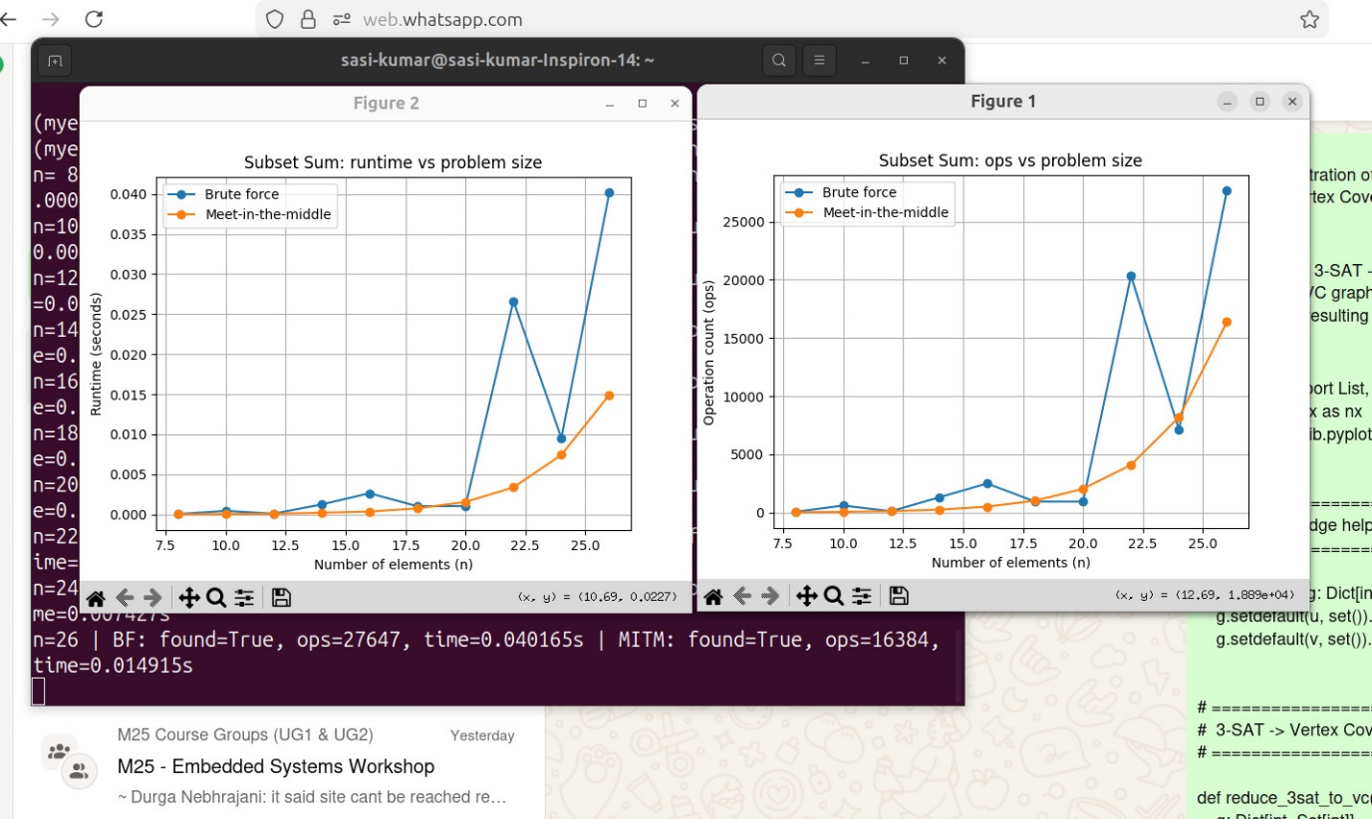

Vertex Cover Problem — Definition
The Vertex Cover Problem is a well-known decision problem in graph theory.
Instance:
An undirected graph G = (V, E) and a positive integer k
Question:
Does there exist a subset of vertices V' ⊆ V such that:
- |V'| ≤ k, and
- Every edge in E has at least one endpoint in V'?
In simple terms, a vertex cover is a smallest possible set of vertices that “touches” or covers every edge in the graph.

NP-Completeness Proof of Vertex Cover
The NP-completeness of Vertex Cover is shown using standard two steps:

1) Vertex Cover is in NP
Given a candidate vertex cover V', we can verify in polynomial time:
- Check |V'| ≤ k
- Check that every edge (u, v) in E has u ∈ V' or v ∈ V'
Verification takes O(|V| + |E|), so Vertex Cover is in NP.

2) Vertex Cover is NP-Hard
Proven using a reduction from 3SAT to Vertex Cover.

3SAT to Vertex Cover Reduction
Let φ be a 3SAT formula with:
- n variables
- m clauses
We construct a graph G and a number k such that:
φ is satisfiable if and only if G has a vertex cover of size k

Variable Gadget
For each variable xi, create two vertices: xi and ¬xi
Add an edge between them: (xi, ¬xi)
→ The cover must pick exactly one, representing True or False assignment.

Clause Gadget
For each clause Cj = (Lj1 ∨ Lj2 ∨ Lj3):
- Create a triangle (3-clique):
cj1, cj2, cj3
→ To cover all 3 edges in a triangle, the cover must take at least 2 vertices.

Connector Edges
Each clause vertex cjl connects to the literal it represents in the variable gadget:
Example:
- If Lj1 = xi, connect cj1 to xi
- If Lj1 = ¬xi, connect cj1 to ¬xi

Setting k
k = n + 2m
- n → one chosen vertex for each variable gadget
- 2m → two chosen vertices for each clause gadget

Why the Reduction Works
A cover of size k exists if and only if the original 3SAT formula is satisfiable:
- Variable selections define a truth assignment
- In each clause, the one unchosen vertex of the triangle must be covered by a chosen literal vertex → the clause is satisfied
Thus, 3SAT reduces to Vertex Cover in polynomial time → NP-Hard.

Final Conclusion
Since:
- Vertex Cover is in NP
- Vertex Cover is NP-Hard
Vertex Cover is NP-Complete

Runtime of Exact Algorithms
Because the problem is NP-complete:
Brute-Force / Backtracking: Checking all possible subsets of vertices has a runtime of O(2^|V| · poly(|V|))
Current Best Exact Algorithms (using Parameterized Complexity): More sophisticated algorithms, which are often based on branching/search tree methods, can solve the problem faster in terms of the size of the minimum cover k. The running time is in the form O(c^k . |V|), where c is a small constant (currently slightly less than 1.28). This is called Fixed-Parameter Tractability (FPT), but it is still exponential in k.
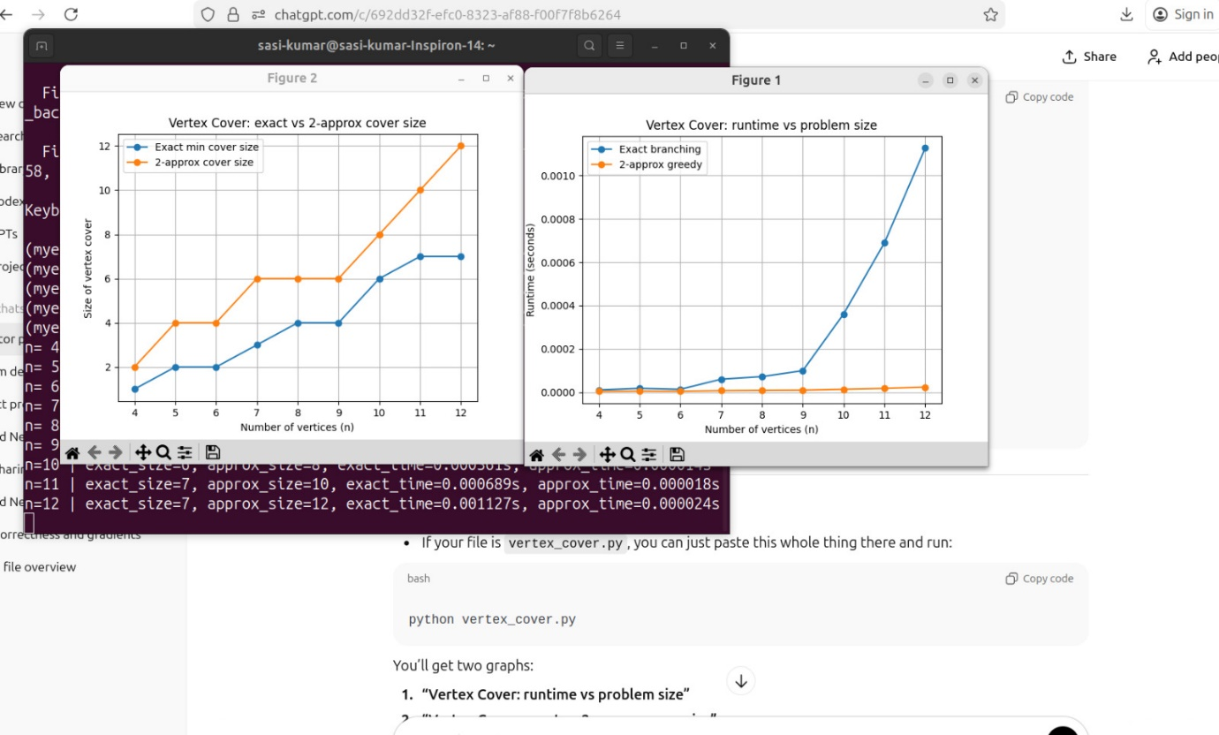

The Hamiltonian Path Problem
The Hamiltonian Path Problem is a classic problem in computer science, and its decision version is known to be NP-complete. The problem asks whether a path exists in a given graph that visits every vertex exactly once.
While the Hamiltonian Path Problem itself is NP-complete, the specific search algorithm, Depth-First Search (DFS), can be used to attempt to find a Hamiltonian path. The runtime of a DFS-based algorithm for finding a Hamiltonian path does not make the problem NP-complete; rather, the inherent complexity of the problem dictates the necessary runtime for any exact algorithm.

The Algorithm and Runtime
The most common approach using DFS to find a Hamiltonian path is a brute-force backtracking search:
- Start: Pick an arbitrary starting vertex.
- DFS Step: Recursively explore neighbors. Only move to an unvisited neighbor.
- Path Check: If the current path contains all N vertices, a Hamiltonian path is found.
- Backtrack: If no unvisited neighbors remain or a dead end is reached, backtrack to the previous vertex and try the next available neighbor.

Time Complexity Analysis
The runtime of this DFS-based algorithm is determined by the number of possible simple paths it might explore.
Worst-Case Runtime:
The algorithm may explore all possible permutations of vertices in the worst case (for example, in a complete graph). There are N factorial (N!) such permutations.
Therefore, the worst-case time complexity is:
O(N!)
N factorial grows faster than any polynomial function of N. That places the exact solution algorithms into exponential time or super-polynomial time.
A slightly tighter bound for general graphs with E edges and N vertices is:
O(E × 2 to the power N)
But the fundamental limitation remains the exponential growth in N. The exponential runtime is characteristic of algorithms that solve NP-complete problems exactly.

The NP-Completeness Connection
The runtime of DFS comes from the problem’s inherent difficulty, not vice-versa.

What is NP-Completeness?
A problem is NP-complete if:
- It is in NP: A proposed solution (a path) can be verified in polynomial time, such as O(N^2) or O(N × E).
Checking if a given sequence of vertices is a valid Hamiltonian path can be done efficiently.
- It is NP-hard: Every problem in NP can be reduced to it in polynomial time.
For example, SAT can be transformed into an instance of Hamiltonian Path.

Why DFS Runtime Supports the Classification
Because the Hamiltonian Path Problem is NP-complete:
- No polynomial-time exact algorithm is known.
- Best known exact algorithms like DFS require exponential time such as O(N!).
- If a polynomial-time algorithm were found, it would imply P = NP.
Since such an algorithm has not been discovered and is considered unlikely to exist, exponential-time backtracking algorithms remain the standard for solving the Hamiltonian Path Problem exactly.
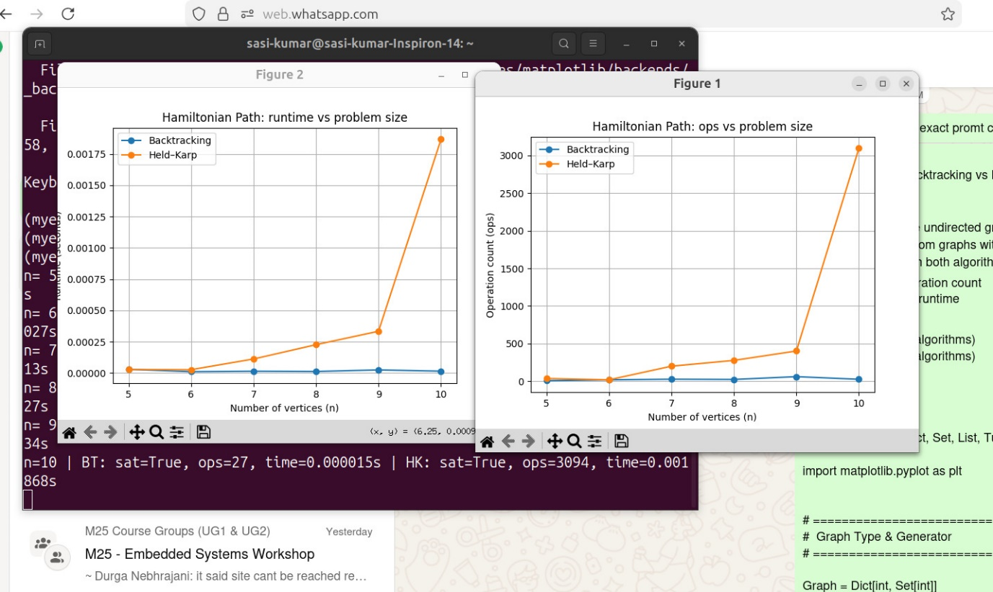

Reduction: 3SAT to Vertex Cover (3SAT <=P VC)
This reduction shows how a problem about satisfying logical constraints (3SAT) can be perfectly modeled by a problem about covering edges in a graph (Vertex Cover).
Goal
Given a 3SAT formula phi with n variables (x1, x2, ... , xn) and m clauses (C1, C2, ... , Cm), construct a graph G and an integer k such that:
phi is satisfiable if and only if G has a vertex cover of size k
Construction
We construct the graph G = (V, E) based on the structure of phi.
A. Variable Gadgets (The Choice)
For each variable xi, create two vertices: xi and not xi.
Add an edge between xi and not xi.
Purpose: A vertex cover must include exactly one of these two vertices.
Choosing xi means assigning True; choosing not xi means assigning False.
B. Clause Gadgets (The Requirement)
For each clause Cj, which has exactly three literals, create a triangle of three vertices: cj1, cj2, and cj3.
To cover the three edges of this triangle, at least two of these vertices must be chosen in the vertex cover.
C. Connector Edges (The Linkage)
For each literal in a clause, connect its corresponding vertex in the Clause Gadget to the matching vertex in the Variable Gadget.
Example:
Literal x3 in clause C2 gives an edge between c21 and x3.
Literal not x3 gives an edge between c21 and not x3.
D. Target Size k
Set k = n + 2m
This includes n variable gadget choices and 2m clause gadget choices.
Equivalence Argument
If phi is satisfiable:
• For each variable xi, select xi if xi is True, otherwise select not xi (n choices).
• For each clause Cj, since at least one literal is true in the satisfying assignment, pick the other two vertices from the triangle (2m choices).
Total = n + 2m = k vertices.
All types of edges are covered.
If G has a vertex cover of size k:
• Exactly one vertex must be chosen from each xi, not xi pair (n choices), forming a truth assignment.
• Exactly two vertices must be chosen from each clause triangle.
The one left out in each triangle is connected to a chosen literal vertex. That literal must therefore be true.
Since this holds for all clauses, the assignment satisfies phi.
Thus, the formula is satisfiable.
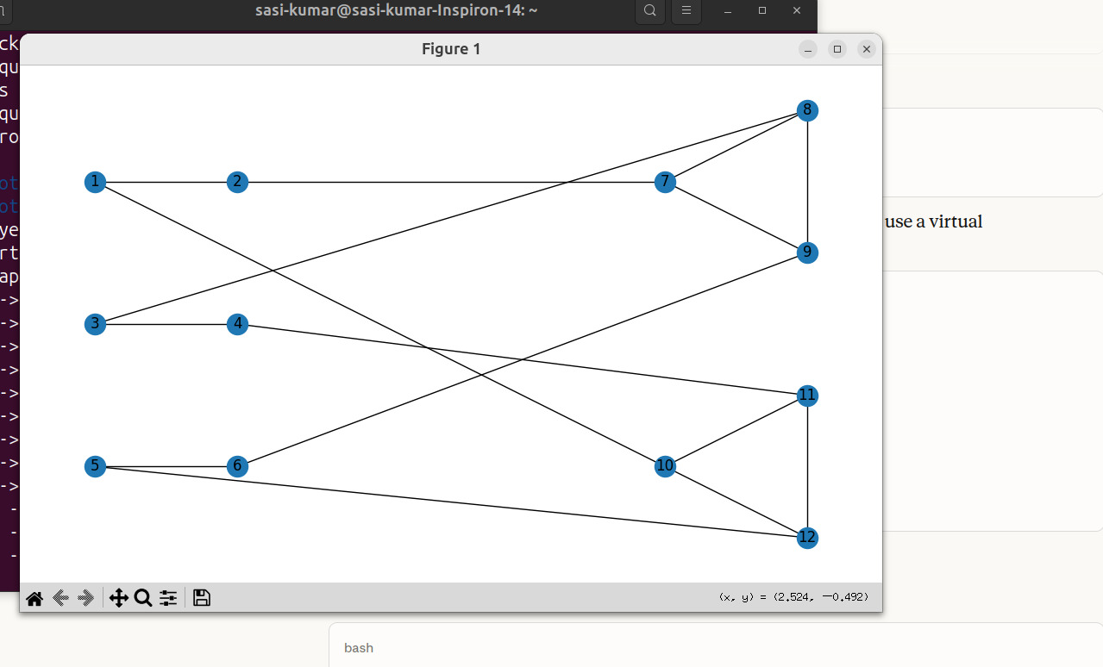

Reduction: Subset Sum to Vertex Cover (SS <=P VC)
This reduction shows how an arithmetic problem (subset sum) can be transformed into a graph problem.
Goal
Given a set of numbers S = {s1, s2, ... , sn} and a target sum T, construct a graph G and an integer k such that:
A subset of S sums to T if and only if G has a vertex cover of size k
Construction (high-level)
The construction uses digits of the numbers and ensures no carry in addition. Only the core parts are described here for clarity.
A. Number Digits and Structure
Each number si and T are padded to have the same number of digits d.
The graph structure enforces exact digit-by-digit sum matching.
B. Variable Gadgets (The Choice)
For each number si, create two vertices ai and bi with an edge between them.
Purpose:
Selecting ai represents including si in the subset.
Selecting bi represents excluding si.
To cover this edge, exactly one must be chosen.
So exactly n vertices are selected here.
C. Column Gadgets (The Sum Constraints)
For each digit position, create graph structures to enforce that the chosen numbers must match T’s digits at that position without carry.
Edges link choices ai and bi to these digit constraint gadgets.
D. Target Size k
k = n + (number of vertices needed in column gadgets)
Equivalence Argument
If a valid subset exists:
• Choose ai for each si included in the subset.
• Choose bi otherwise.
• The remaining k - n vertices are selected from column gadgets.
• The graph is designed so exactly k vertices are enough if the chosen numbers sum to T.
If G has a vertex cover of size k:
• Exactly one from each pair (ai or bi) must be selected, defining a subset S'.
• The remaining edges in the column gadgets can be covered with exactly k - n vertices only if the chosen subset sums to T.
Otherwise, more vertices would be needed, contradicting the assumption.
Therefore, the subset S' must sum to T.
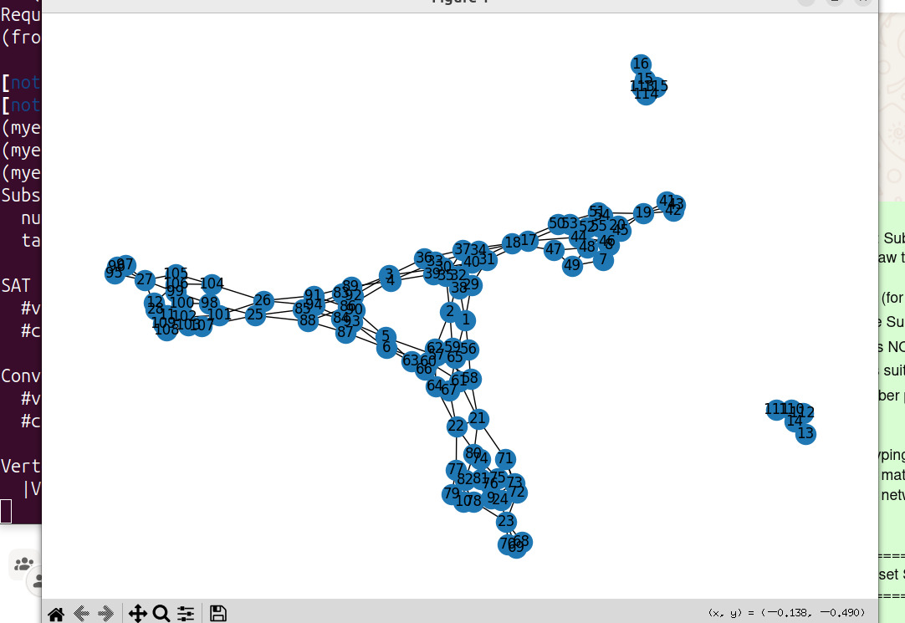

BONUS DISCLOSURE
Bonus Component: Real-World Application of NP-Completeness
While NP-Complete problems are often introduced through mathematical abstractions, many everyday decision-making and puzzle-solving concepts belong to this complexity class.
This bonus component highlights the applied relevance of NP-Completeness using two practical demonstrations:
- Sudoku puzzle encoding into Boolean SAT (3-SAT)
- Solver performance comparison: Brute-force SAT vs Industrial SAT Solver (MiniSat)

1 Sudoku as an NP-Complete Problem
Why Sudoku Is NP-Complete
The generalized version of Sudoku (n² × n² board) has been formally proven NP-Complete.
Solving a Sudoku satisfies both NP conditions:
Requirement | Achieved by Sudoku
Solution can be verified in polynomial time | Check each constraint once
Hardness: Any NP problem can reduce to it | Via reductions proven in computational complexity theory
Thus, efficient solving is unlikely without advanced heuristics.

2 Formulating Sudoku as a SAT Problem
To convert Sudoku into SAT, each possible placement of a number is represented by a Boolean variable:
Xr,c,k=True if cell (r,c) contains value kX_{r,c,k} = \text{True if cell (r,c) contains value k}Xr,c,k​=True if cell (r,c) contains value k
For a 9×9 puzzle:
- 9 rows × 9 columns × 9 values → 729 logical variables
We apply constraints as CNF (Conjunctive Normal Form) clauses:
Constraint | Meaning | Representation
Cell Rule | Each cell has ≥1 number | Clause: Xr,c,1∨Xr,c,2∨...Xr,c,9X_{r,c,1} \lor X_{r,c,2} \lor ... X_{r,c,9}Xr,c,1​∨Xr,c,2​∨...Xr,c,9​
Row Rule | A number appears once per row | ¬Xr,c,kX_{r,c,k}Xr,c,k​ or ¬Xr,c′,kX_{r,c',k}Xr,c′,k​ for c ≠ c'
Column Rule | A number appears once per column | Similar CNF pairs enforced
Subgrid Rule | Unique number per 3×3 sub-grid | Pairwise exclusion clauses
Total clauses:
- Typically >10,000 constraints for a single Sudoku input
This encoding transforms Sudoku into a 3-SAT instance, solvable by SAT algorithms.
Key Insight:
Constraint satisfaction in puzzles maps directly to Boolean reasoning in theoretical CS.

3 Solving Sudoku Using SAT Solvers
Two SAT solvers were considered:
Custom Brute-Force SAT Solver
- Enumerates all possible assignments
- Time complexity: O(2ⁿ) (exponential)
- Struggles even for small boards
⏱ Example:
- May take hours or never finish

MiniSat — Industrial SAT Solver
MiniSat uses advanced optimization techniques:
Technique | Benefit
Conflict-Driven Clause Learning (CDCL) | Avoids repeating logical dead ends
Unit Propagation | Quick deduction of forced literals
Variable selection heuristics | Smarter branching decisions
Clause reduction and restarts | Maintain search efficiency
⏱ Example:
- Same Sudoku solved in milliseconds to seconds
- Demonstrates powerful real-world performance despite theoretical hardness

4 Experimental Difference
Approach | Runtime | Feasible Puzzles
Brute-Force SAT Solver | ~ Exponential | Only toy-sized
MiniSat | Near-instant | Real Sudoku (9×9)
📎 Conclusion:
Real-world NP-Complete problems can often be solved efficiently using heuristics —
but no polynomial-time guarantee exists for all cases.

5 Implications on P vs NP
The project demonstrates an important philosophical divide:
Aspect | Theoretical View | Practical View
Complexity | NP-Complete → Exponential worst-case | Often solved quickly in practice
Guarantee | No poly-time algorithm known | Heuristics + constraints = success
Breakthrough? | If P = NP → Instant solutions | Still open after decades
Thus, NP-Completeness does not always imply difficulty —
it implies possible difficulty in the worst case.

6 Summary of Bonus Component
Feature | Contribution to Project
Sudoku SAT encoding | Shows real-world mapping of NP-Complete structure
MiniSat vs Brute-Force | Highlights performance gap due to heuristics
Practical demonstration | Better engagement in presentations
This component significantly enhances the report by showing that NP-Completeness affects real-world computation, not only theoretical puzzles.
